TP 3 :

PUBS :

R1 : (0 row(s) affected)

SELECT t.title_id, t.title, t.type

FROM titles t WHERE NOT EXISTS(SELECT title_id FROM sales);



R2 : (0 row(s) affected)

SELECT a.au_id, a.au_lname, a.au_fname

FROM titleauthor ta JOIN authors a ON ta.au_id = a.au_id

WHERE NOT EXISTS(SELECT title_id FROM sales)



R3 : (25 row(s) affected)

SELECT a.au_id, a.au_fname, a.au_lname

FROM authors a JOIN titleauthor ta ON a.au_id = ta.au_id

JOIN titles t ON ta.title_id = t.title_id

JOIN publishers p ON t.pub_id = p.pub_id

WHERE p.country = 'USA'

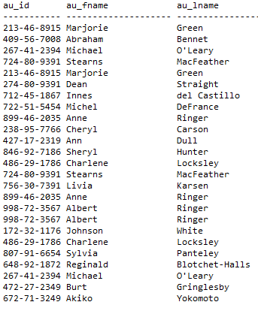

R4 : (10 row(s) affected)

SELECT pub_name, type, YEAR(ord_date) as annee, sum(qty) as exemplaires_vendus

FROM titles t JOIN sales s ON t.title_id = s.title_id

JOIN publishers p ON t.pub_id = p.pub_id

GROUP BY pub_name, type, YEAR(ord_date)

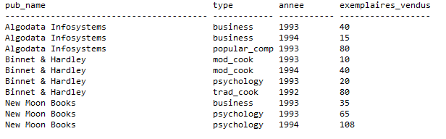

R5 : (5 row(s) affected)

SELECT s.stor_name, s.city

FROM stores s JOIN sales sa ON s.stor_id = sa.stor_id

JOIN titles t ON sa.title_id = t.title_id

WHERE t.type = 'business'

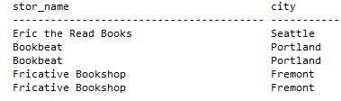

R6 : (17 row(s) affected)

SELECT p.city, p.country, p.pub_name, s.stor_name, t.type, YEAR(sa.ord_date) AS annee, SUM (price * qty) AS CA

FROM stores s JOIN sales sa ON s.stor_id = sa.stor_id

JOIN titles t ON sa.title_id = t.title_id

JOIN publishers p ON t.pub_id = p.pub_id

GROUP BY p.city, p.country, p.pub_name, s.stor_name, t.type, YEAR(sa.ord_date)

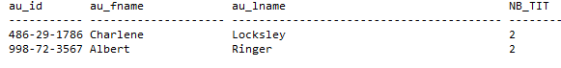

R7 : (2 row(s) affected)

SELECT a.au_id, a.au_fname, a.au_lname, COUNT(DISTINCT t.title_id) as NB_TIT

FROM authors a JOIN titleauthor ta ON a.au_id = ta.au_id

JOIN titles t ON t.title_id = ta.title_id

WHERE ta.au_ord = 1

GROUP BY

a.au_id, a.au_fname, a.au_lname

HAVING COUNT(DISTINCT t.title_id)>=2

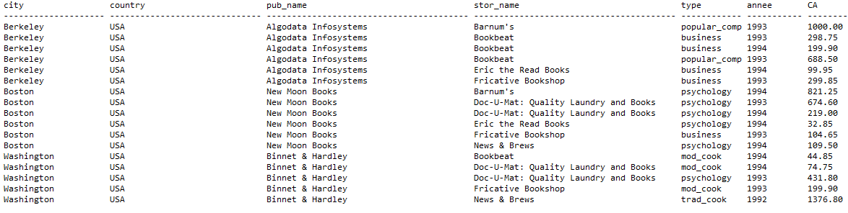

R8 : (43 row(s) affected)

SELECT pub_name, job_desc, COUNT(e.emp_id) AS NB_EMP

FROM jobs j JOIN employee e ON j.job_id = e.job_id

JOIN publishers p ON e.pub_id = p.pub_id

GROUP BY pub_name, job_desc

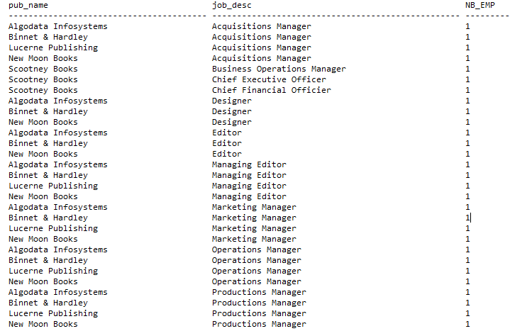

R9 : (4 row(s) affected)

SELECT pubName, annee, SUM( CASE WHEN titleID IS NULL THEN 0 ELSE 1 END) AS nombre_livres_vendus, SUM(CASE WHEN titleID IS NULL THEN 1 ELSE 0 END) AS nombre_livres_non_vendus

FROM

(SELECT t.title_id AS titleID,

p.pub_name AS pubName, YEAR(t.pubdate) as annee

FROM

publishers p JOIN titles t ON p.pub_id = t.pub_id

RIGHT JOIN sales s on s.title_id = t.title_id) as T

GROUP BY pubName, annee

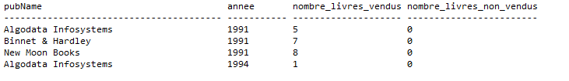

R10 : (20 row(s) affected)

SELECT a.au_fname, a.au_lname,

YEAR(t.pubdate) as ANNEE ,

SUM (CASE WHEN au_ord = 1 THEN 1 ELSE 0 END) AS NBLAP,

SUM(CASE WHEN au_ord !=1 THEN 1 ELSE 0 END ) AS NBLAC

FROM authors a JOIN titleauthor ta on a.au_id = ta.au_id

JOIN titles t on t.title_id = ta.title_id

GROUP BY a.au_fname, a.au_lname, YEAR(t.pubdate)

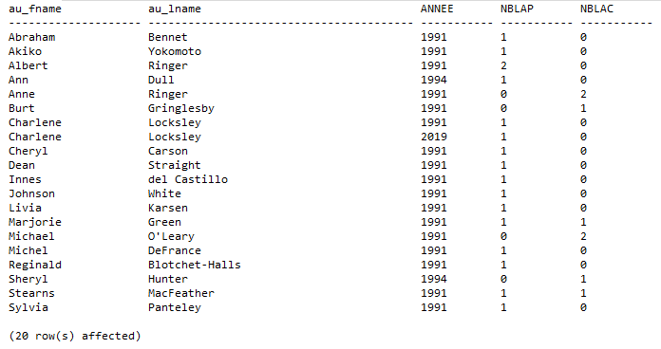

NORTHWIND :

R1 : (806 row(s) affected)

SELECT c.CustomerID, c.ContactName, c.City, c.Country,

e.EmployeeID, e.FirstName, e.LastName, e.City as EmployeeCity, e.Country as EmployeeCountry,

DATENAME(m,o.OrderDate)+' '+CAST(DATEPART(yyyy,o.OrderDate) as varchar) as mois,

YEAR(o.OrderDate) as annee,

SUM(CASE WHEN o.ShippedDate IS NULL THEN 0 ELSE 1 END) AS NB_CM_LIVREES,

SUM(CASE WHEN o.ShippedDate IS NULL THEN 1 ELSE 0 END) AS NB_CM_NON_LIVREES

FROM Customers c JOIN Orders o ON c.CustomerID = o.CustomerID

JOIN Employees e ON o.EmployeeID = e.EmployeeID

GROUP BY c.CustomerID, c.ContactName, c.City, c.Country,

e.EmployeeID, e.FirstName, e.LastName, e.City, e.Country,

datename(m,o.OrderDate)+' '+cast(datepart(yyyy,o.OrderDate) as varchar),

YEAR(o.OrderDate)

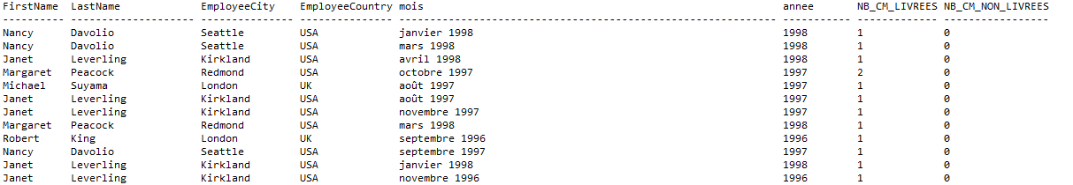

R2 : (67 row(s) affected)

SELECT COUNT(DISTINCT p.ProductID) as NB_Produits ,

s.SupplierID, s.ContactName, s.City, s.Country,

c.CategoryID, c.CategoryName,

CASE

WHEN p.UnitPrice BETWEEN 1 AND 50 THEN 'P1'

WHEN p.UnitPrice BETWEEN 51 AND 100 THEN 'P2'

WHEN p.UnitPrice>100 THEN 'P3'

END AS Niveau_Prix,

CASE

WHEN p.UnitsInStock = 0 THEN 'S0'

WHEN p.UnitsInStock BETWEEN 1 AND 30 THEN 'S1'

WHEN p.UnitsInStock >30 THEN 'S2'

END AS Niveau_Stock

FROM Products p JOIN Suppliers s ON p.SupplierID = s.SupplierID

JOIN Categories c ON p.CategoryID = c.CategoryID

GROUP BY s.SupplierID, s.ContactName, s.City, s.Country,

c.CategoryID, c.CategoryName,

(CASE

WHEN p.UnitPrice BETWEEN 1 AND 50 THEN 'P1'

WHEN p.UnitPrice BETWEEN 51 AND 100 THEN 'P2'

WHEN p.UnitPrice>100 THEN 'P3'

END),

CASE

WHEN p.UnitsInStock = 0 THEN 'S0'

WHEN p.UnitsInStock BETWEEN 1 AND 30 THEN 'S1'

WHEN p.UnitsInStock >30 THEN 'S2'

END

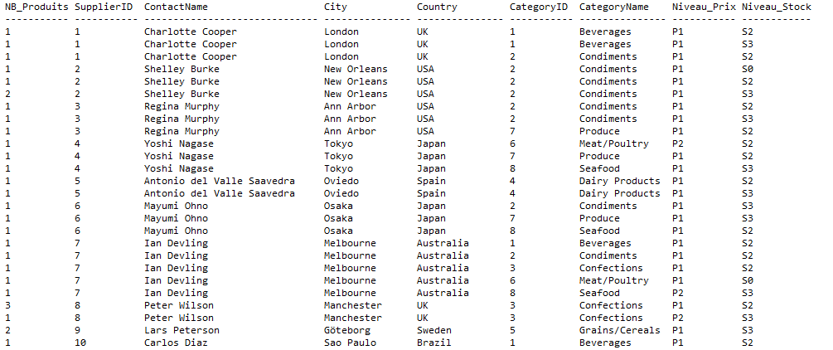

R3 : (79 row(s) affected)

SELECT City, Country,

CASE

WHEN CA BETWEEN 100 AND 10000 THEN 'Low'

WHEN CA BETWEEN 10001 AND 80000 THEN 'Medium'

WHEN CA > 80000 THEN 'High'

END AS SalesLevel,

CASE

WHEN NB_COMMANDES BETWEEN 1 AND 10 THEN 'Low'

WHEN NB_COMMANDES BETWEEN 11 AND 20 THEN 'Medium'

WHEN NB_COMMANDES > 20 THEN 'High'

END AS OrderLevel,

COUNT(CustomerID) as NB_CLIENTS

FROM

(SELECT C.CustomerID, C.City, C.Country,

Sum(OD.UnitPrice * OD.Quantity -(OD.UnitPrice * OD.Quantity * OD.Discount)) AS CA,

COUNT(OD.OrderID) AS NB_COMMANDES

FROM

Customers C JOIN Orders O ON C.CustomerID = O.CustomerID

JOIN [Order Details] OD ON O.OrderID = OD.OrderID

GROUP BY C.CustomerID, C.City, C.Country) AS T1

GROUP BY City, Country,

CASE

WHEN CA BETWEEN 100 AND 10000 THEN 'Low'

WHEN CA BETWEEN 10001 AND 80000 THEN 'Medium'

WHEN CA > 80000 THEN 'High'

END,

CASE

WHEN NB_COMMANDES BETWEEN 1 AND 10 THEN 'Low'

WHEN NB_COMMANDES BETWEEN 11 AND 20 THEN 'Medium'

WHEN NB_COMMANDES > 20 THEN 'High'

END

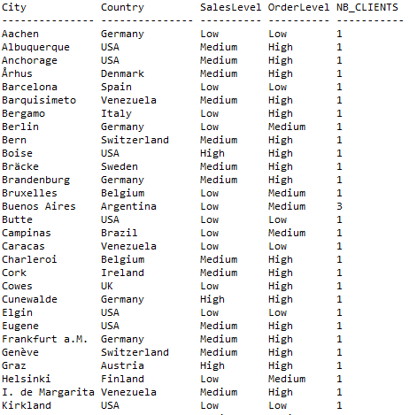

R4 : (2123 row(s) affected)

SELECT DATENAME(m,O.OrderDate) as Mois, YEAR(O.OrderDate) as Annee,

C.CustomerID, C.ContactName, C.City, C.Country,

P.ProductID,P.ProductName,

Ca.CategoryID, Ca.CategoryName,

SUM(CASE WHEN O.ShippedDate IS NULL THEN 0 ELSE OD.UnitPrice * OD.Quantity -(OD.UnitPrice * OD.Quantity * OD.Discount) END) AS CA_Realise,

SUM(OD.UnitPrice * OD.Quantity -(OD.UnitPrice * OD.Quantity * OD.Discount)) AS CA_Commande

FROM

Customers C JOIN Orders O ON C.CustomerID = O.CustomerID

JOIN [Order Details] OD ON O.OrderID = OD.OrderID

JOIN Products P ON OD.ProductID = P.ProductID

JOIN Categories Ca ON P.CategoryID = Ca.CategoryID

GROUP BY

DATENAME(m,O.OrderDate),YEAR(O.OrderDate),

C.CustomerID, C.ContactName, C.City, C.Country,

P.ProductID,P.ProductName,

Ca.CategoryID, Ca.CategoryName

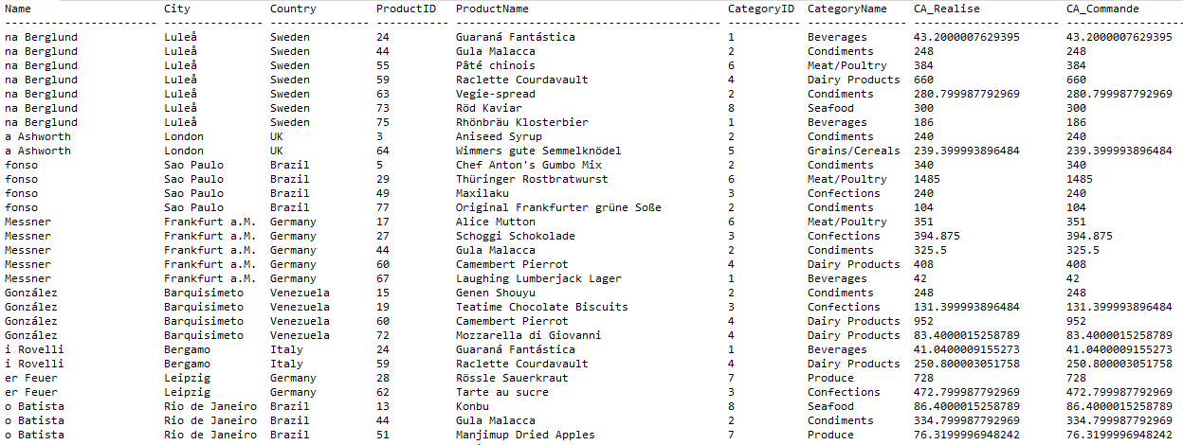

R5 : (890 row(s) affected)

SELECT SUM(OD.Quantity * OD.UnitPrice * OD.Discount) AS Valeur_Remise,

DATENAME(m,O.OrderDate) AS Mois, YEAR(O.OrderDate) AS Annee,

C.CustomerID, C.ContactName, C.City, C.Country,

OD.Discount

FROM

Customers C JOIN Orders O ON C.CustomerID = O.CustomerID

JOIN [Order Details] OD ON O.OrderID = OD.OrderID

GROUP BY

DATENAME(m,O.OrderDate), YEAR(O.OrderDate),

C.CustomerID, C.ContactName, C.City, C.Country,

OD.Discount

